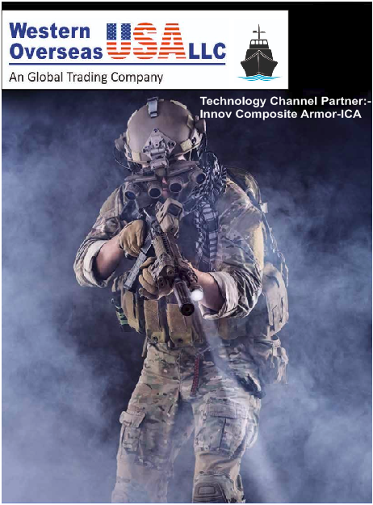

**BODY ARMOR PROTECTION**

With years of research and a team of experts, we at INNOV COMPOSITE ARMOR **(ICA)** is focused on establishing a state-of-the-art facility focusing on the development of quality body armor for a variety of applications.

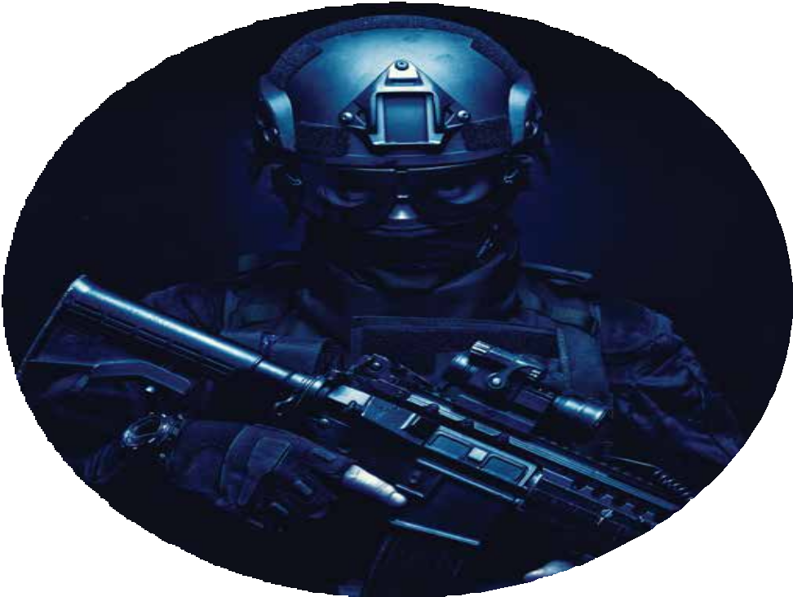

###### With a successful history in the Design & Manufacturing ﬁeld, we’ve extended our technical knowledge of the unique composite properties of the materials required to develop the highest quality protective gear for various defence and defensive-offence personnel, both government and private.

We use a variety of Aramid, Polyethylene, glass ﬁbre, ceramic, steel and hybrid materials in our ballistic armour, and perform our tests in international/national standard laboratory arrangements to ensure the highest of quality control norms as per International Standards on all our products.

 BULLET RESISTANT JACKETS

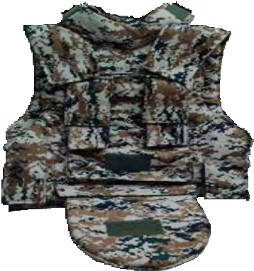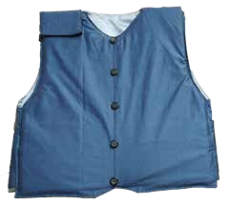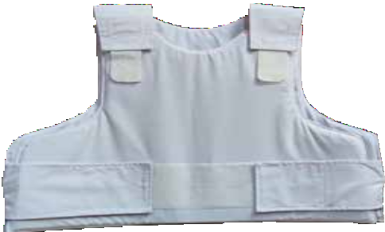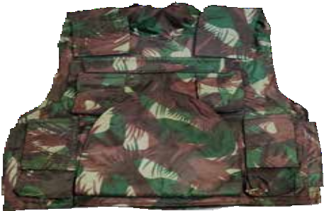

At INNOV COMPOSITE ARMOR **(ICA),** we manufacture a complete range of BULLET-RESISTANT JACKETS for covert, overt, law-enforcement, naval and military usage. The ergonomic shapes, combined with lightweight armour plates and an increased area of protection aids in mobility and ﬁt, without compromising on protection.

**PRODUCT NAME: COMMANDO C1**

**PROTECTION : NIJ LEVEL III or BIS III**

**STANDARD PROTECTION FEATURES:**

* Fully modular tactical armour package
* Front/rear HAP pockets, ultra-lightweight, high performance polyethylene plate, Dedicated groin panel
* Adjustable & full-coverage collar system
* Rear waist band wrap-around.
* Integrated magazine & grenade pouches
* Water resistant SAP pouches with thermal sealing
* Removable Nylon/CORDURA carrier

**PRODUCT NAME: TACTICAL VEST X1 PROTECTION : NIJ LEVEL III+ or BIS V STANDARD PROTECTION FEATURES:**

* Fully modular tactical armour package
* Front/rear HAP pockets, high mobility tactical cut for ease of movement
* Dedicated groin & over-the-shoulder armour panels
* Adjustable & full-coverage collar system
* Rear waist band wrap-around.
* Integrated magazine & grenade pouches
* Water resistant SAP pouches with thermal sealing
* Removable Nylon/CORDURA carrier

**PRODUCT NAME: DIPLOMAT VEST PROTECTION : NIJ LEVEL II/IIIA or BIS I STANDARD PROTECTION FEATURES:**

* Ultra ﬂexible soft armour panel system. Padded shoulder.
* Velcro side-strap adjustable locking
* 3-Piece suit design. V/Round Neck Styling
* Removable terricot/wool carrier styling (internal silky fabric optional)
* Water resistant SAP pouches with thermal sealing

**PRODUCT NAME: CONCEALABLE VEST**

**PROTECTION : NIJ LEVEL II/IIIA STANDARD PROTECTION FEATURES:**

* Ultra ﬂexible soft armour panel system. Padded shoulder.
* Velcro side-strap adjustable locking
* Double elastic waist straps.
* Removable poly/cotton carrier styling (Internal spacer fabric optional)
* Water resistant SAP pouches with thermal sealing
* Custom pouches optional

## HEAD GEAR

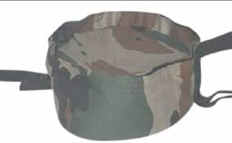PRODUCT NAME : PATKA

**PROTECTION: NIJ LEVEL IIIA or NIJ LEVEL II / III+**

The Patka is a unique piece of headgear that is worn over a turban. It is indigenously developed as an alternative to a helmet for turbaned soldiers. This piece of headgear is designed to protect the wearer from multiple lethal rounds, thereby providing vital head protection.

FEATURES:

INNOV COMPOSITE ARMOR (ICA) Ultralight material for superior protection and comfort.

Ballistic strip made of high-density ballistic steel/composite construction. Cushioned harness material for additional comfort, with chin-cup.

Compatible with modern communication devices and Night Vision Devices.

ADDITIONAL FEATURES:

Protects against 9mm FMJ along its circumference Forehead ballistic strip – 250x75mm

Can withstand frontal AK-47 ﬁre from a distance of 25 meters & 9mm pistol ﬁre at the rear from a distance of 10 meters.

PRODUCT NAME : BALLISTIC HELMET PROTECTION: NIJ LEVEL II or IIIA

The PASGT or MICH helmet is an ideal pick for its light-weight and highly protective design. Developed using ballistic aramide, this helmet is constructed using a hot pressing technique (High Tonnage Compression moulding) giving it the unique “shell” shape.

FEATURES:

3 or 4 point suspension system. 4 point chin strap harness. Integrated nape pad. Crown mesh with cross straps; with plastic cup/web holding.

Leather ring: Shock absorption harness, leather webbing, leather chin strap. Pad: 7 EVA/XLMPE foam pads.

ADDITIONAL FEATURES:

Protects against pistol/SMC ﬁre & fragments Weight Range: 1.15kg – 1.50kg

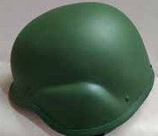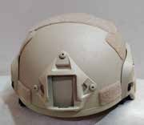

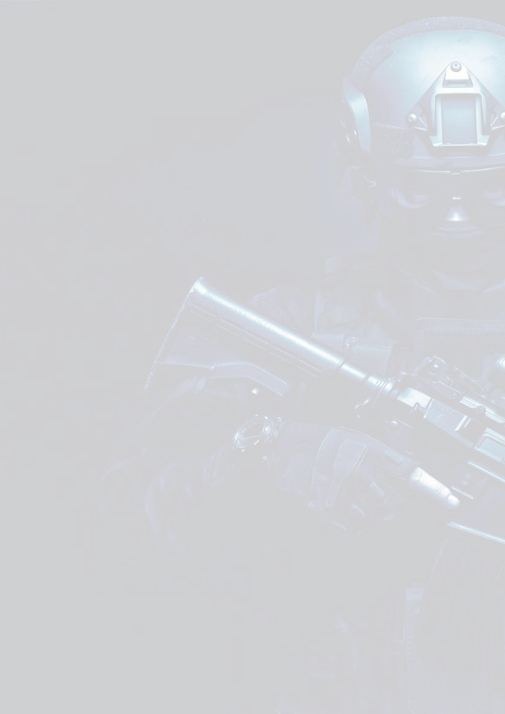**PASGT**

PASGT Helmets (Personnel Armour System Ground Troops) provides protection against fragments/sharp objects and other ballistic threats; with desired comfort. Used by; special forces, para, police, military and SWAT personnel.

##### MICH

MICH Helmet (Modular Integrated Communications Helmet). A lighter and more compact version of the PASGT, with reduced ear coverage, no lip coverage, and reduced coverage at the back. The MICH allows for better clarity of vision and hearing while allowing ease of shooting from a prone position.



## BALLISTIC SHIELD

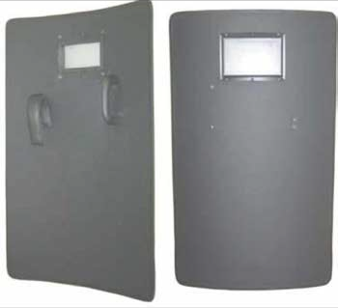PROTECTION: NIJ Level IIIA or NIJ Level III/III+

Designed to stop or deﬂect bullets ﬁred at their carrier, INNOV COMPOSITE ARMOR (ICA) Ballistic Shields are upper-torso or whole-body protection devices utilized by police and military forces. Also conferring protection from less serious threats such as projectile items, ICA Shields are modular multiple role personnel protection shields for missions and training within a dynamic environment.

Features:

* Made of UHMWPE or pre-pregs / Aramid ﬁbres, ICA Shields are ergonomically efficient to be carried into restricted spaces,

and are optimal for climbing ladders or covering long distances over rugged terrain.

* With clear armoured viewing ports, ambidextrous handles, and varied sizes, the shields can be utilized as the user deems necessary — handheld, or mounted on wheel-based frames.
* Can be carried on one arm without necessarily holding the hand grip while climbing in ascent or descent.
* Unique hands-free carriage on the arms allows the user to conduct normal weapon stoppage drills.

Additional Features:

* Modular harness incorporates shoulder straps, enabling the user to carry it on their back even while fast-roping from helicopters.
* Ballistic shock absorber to attenuate shock transfer to the user’s arm.



* Built-in buoyancy — the user can swim whilst having the shield attached or ﬂoating beside them. This is a major safety factor for maritime boarding operations.

## BALLISTIC BLANKET

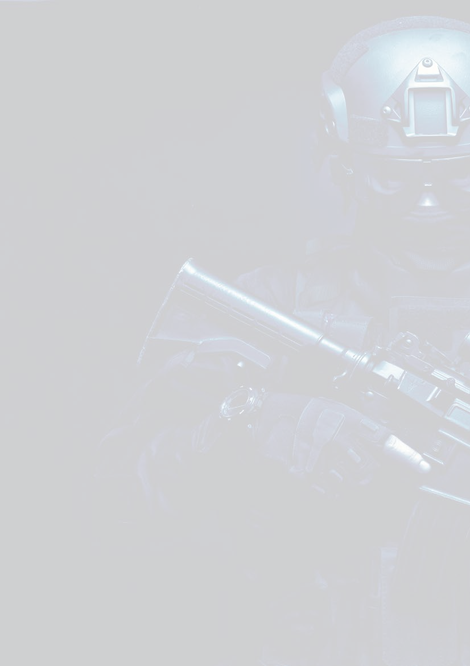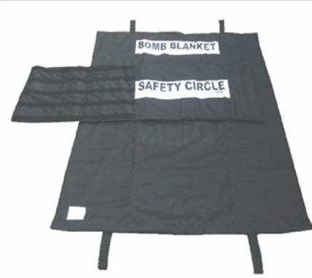

PROTECTION: V50 17 grain steel fragments 500 m/s 100 gram IED

Designed to evacuate from hostile situations, mitigate blast detonations and minimise the risk of secondary fragmentation from Improvised Explosive Devices (IEDs), Ballistic Blankets are effective against pipe bombs, hand grenade fragments, and fragmentation caused by pressure/electrical explosions.

Manufactured utilizing Aramid technologies that stitch layers of Kevlar with other proprietary materials, Ballistic Blankets provide a lightweight and ﬂexible bomb suppression blanket optimized for blast impact protection.

Features:

* + IED/IOD operations.
  + Demining operations.
  + Blast suppression in nuclear facilities, high-risk government and non-government buildings.
  + Ballistic-blast protection in vehicle and aircraft interiors and ﬂooring.
  + Weight depends on threat perception. Can be designed to meet custom threat requirements.



    
    
    

